The full paper will be published in a special issue of The Asia-Pacific Journal of Molecular Biology and Biotechnology (APJMBB) https://www.msmbb.my/index.php/publication
Papers must be written in English.

You can find the details of the manuscript guidelines HERE

Manuscripts should be submitted through APJMBB online submission system HERE. Please refer to the technical guide HERE.

FULL PAPER GUIDELINES

- Manuscript must be in Microsoft Word, using Garamond font, size 12, unless indicated otherwise.
- The title, abstract and keywords should be prepared based on the following criteria:
Title: The title should not exceed 20 words in length.
Abstract: The abstract should be less than 250 words, highlighting the background, problem statement, hypothesis, methodology, findings, and conclusion of the study in a single paragraph. Keywords: A maximum of 6 keywords relevant to the manuscript can be provided in alphabetical order for indexing purposes.
- Manuscript Structure
a) Introduction: Introduce the research topic, providing background, research problems and stating the objectives.
b) Materials and Methods: Detail the methodology, including materials, procedures, ethical statement (if any) and statistical analysis.
c) Results or Results and Discussion: Present the results (and discussion, if combined) of the study with appropriate tables and figures.
d) Discussion (If separated from Results): Provide your discussion and interpretation of the results, discussing their implications and limitations.
e) Conclusion: Summarize the main findings and suggest future research directions.
f) Acknowledgements: Provide your acknowledgements. Otherwise, state the following: None.
g) Conflict of Interest: Competing interests that might interfere with the objective presentation of the research findings contained in the manuscript should be declared.
h) Funding: Provide your funding details. Otherwise, state the following: None.
i) Ethics Statement: Experimental research involving humans or animals should have been approved by the author's institutional review board or ethics committee. Then the name of the authorising body should be stated. Otherwise, state the following: Not applicable.
j) References: The journal follows the APA 7th edition reference style:
The citation style presets can be downloaded at EndNote, Mendeley or Zotero.

- Figures, Tables and Supplementary Documents

Figures: Provide all illustrations and photographs of high quality and their captions at the end of the template (Refer to the image below). Do not include any image borders to your images. Any text or icons added to the image should be embedded into the image and not overlaid.
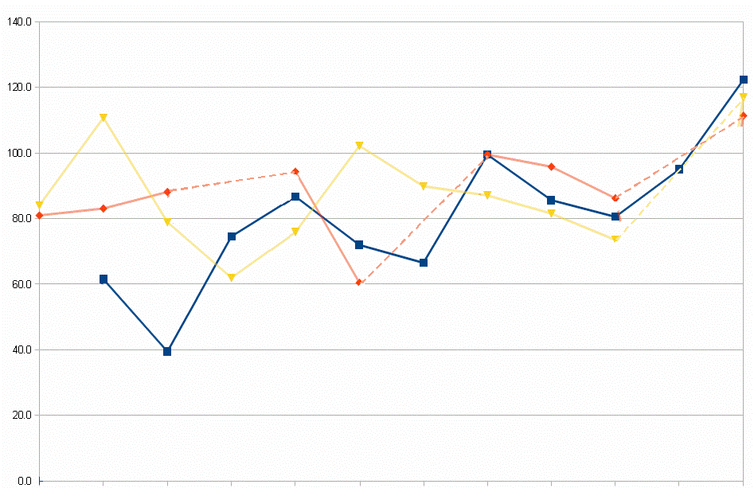
Figure 1: Figure caption

Tables: Include tables at the end of the template, each on a separate page. Tables should be numbered consecutively (Table 1, Table 2, etc). Each tables should have an appropriate caption, contain only horizontal rules (one above and one below column headings), and all abbreviations should be clearly explained in the footnote.

Table 1. Table title
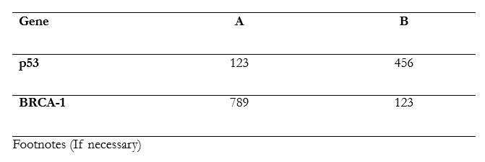

Supplementary Documents: Supplementary figures can be saved in a separate file in Word/PDF format.

- Symbols, SI Units, Abbreviations, Super/Subscripts and Equations
a) Symbols: Ensure that all symbols are in Garamond Font, size 12.
b) SI Units and Abbreviations: Authors must follow the SI system of units. Non-standard abbreviations should be used only when they are used multiple times and should be defined on their first appearance in both the main body of the text and the abstract.
c) Super/Subscripts: The numbers in chemical compounds should be formatted using super/subscripts only. For example: H₂0 or Fe³⁺. Do not use equations or a different font for this function.
d) Equations: Equations should be provided using the “Equation” function in Word. By default, the font for equations should be Cambria Math (font size: 11). Include the equation in the text in the paragraph directly after it is first mentioned.

- Authorship, Plagiarism, Copyright Policy
a) Authorship: Ensure that all listed authors meet the criteria for authorship and have approved the final manuscript.
b) Plagiarism: The journal has zero tolerance for plagiarism, including self-plagiarism. Manuscripts are screened throughout; if any issues are detected, the paper is rejected. If published work is plagiarised, it will be retracted, and authorities will be notified. The maximum allowed similarity is 20% using Turnitin.
c) Copyright Policy: The AJMBB requires the corresponding author to sign a copyright transfer agreement and a letter of undertaking on behalf of all authors. These documents are sent to the corresponding author when the manuscript is accepted and scheduled for publication.

- Review Process
The journal employs a single-blind peer review process. Manuscripts sent for review will include author names and affiliations. Typically, two or more experts will evaluate whether the manuscript is scientifically sound, coherent, not duplicate work, and clear enough for publication. The Academic Editors will decide based on these reports and consult the Editorial Board if needed. The corresponding author will usually be notified within 3 months of submission about acceptance, rejection, or required modifications. If modifications are requested, resubmission should occur within 2 weeks; otherwise, the manuscript is considered withdrawn.

- Formatting by Authors Upon Acceptance
Upon acceptance for publication, authors are advised to provide a final version of the manuscript in Microsoft Word, in accordance with the journal formatting guidelines. Please ensure that all figures are high resolution with 300 dpi. If graphs or charts are prepared using Microsoft Excel, please provide a soft copy of the Excel file.

- Article Processing Charges (Effective 1 January 2025 onwards)
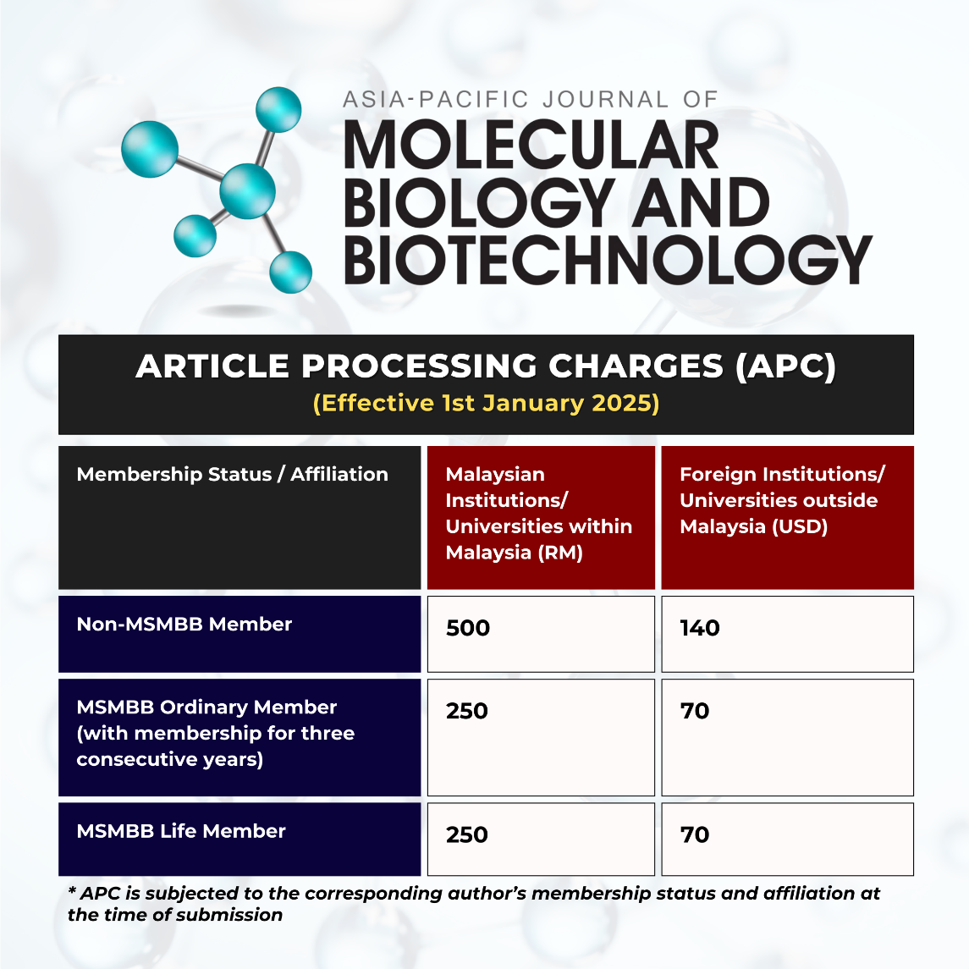
Contact Information: For any queries regarding manuscript submission, please contact our editorial team at admins@mterms2026.com

